**Table #**

*Number of Missing Scores per Variable*

| Variable | *N* Missing | % Missing |
| --- | --- | --- |
| Age | 103 | 9.09% |
| Gender | 41 | 3.62% |
| Consumer Behaviors | 18 | 1.59% |
| Self-deceptive Enhancement | 15 | 1.32% |
| Impression Management | 14 | 1.24% |
| Biospheric Values | 14 | 1.24% |
| Egoistic Values | 14 | 1.24% |
| Altruistic Values | 13 | 1.15% |
| Hedonic Values | 13 | 1.15% |
| Clothing Interest | 0 | 0% |
| Framing Condition | 0 | 0% |
| Norm Condition | 0 | 0% |
| Consumer Intentions | 0 | 0% |

*Note.* Total sample size was *n* = 1,133.

**Table #**

*Sample Size per Condition*

|  | Framing Condition | | |  |
| --- | --- | --- | --- | --- |
| Norm Condition | Control | Pro-environmental | Self-enhancing | Total *n* per Norm |
| Control | 79 | 73 | 79 | 231 |
| Descriptive Norm | 71 | 76 | 80 | 227 |
| Convention | 66 | 85 | 77 | 228 |
| Social Norm | 91 | 67 | 64 | 222 |
| Moral Norm | 68 | 80 | 77 | 225 |
| Total *n* per Framing | 375 | 381 | 377 |  |

*Note.* Total sample size was *n* = 1,133.

**Table #**

*Estimated Marginal Means for Consumer Intentions across Norm and Framing Conditions*

|  | Framing Condition | | |  |
| --- | --- | --- | --- | --- |
|  | Control | Pro-environmental | Self-enhancing | Per Norm Condition |
| Norm Condition | *EMM* (*SE*) | *EMM* (*SE*) | *EMM* (*SE*) | *EMM* (*SE*) |
| Control | 4.45 (0.12) | 4.61 (0.13) | 4.24 (0.13) | 4.43 (0.07) |
| Descriptive Norm | 4.29 (0.13) | 4.44 (0.13) | 4.47 (0.12) | 4.40 (0.07) |
| Convention | 4.50 (0.14) | 4.54 (0.12) | 4.47 (0.13) | 4.50 (0.07) |
| Social Norm | 4.16 (0.12) | 4.42 (0.13) | 4.24 (0.14) | 4.28 (0.08) |
| Moral Norm | 4.23 (0.14) | 4.38 (0.12) | 4.38 (0.13) | 4.33 (0.08) |
| Per Framing Condition | 4.33 (0.06) | 4.48 (0.06) | 4.36 (0.06) |  |

*Note.* Estimated marginal means from the regression model predicting consumer intentions detailed in Table 1.

**Table #**

*Descriptive Statistics for Variables with No Missing Data*

| Variable | *n* | *M* | *SD* | *Skew* | *Min* | *Max* | *Mdn* |
| --- | --- | --- | --- | --- | --- | --- | --- |
| Clothing Interest | 1133 | 3.13 | 0.80 | -0.18 | 1 | 5 | 3.15 |
| Ingroup Identification | 1133 | 4.64 | 1.01 | -0.27 | 1 | 7 | 4.64 |
| Consumer Intentions | 1133 | 4.41 | 1.19 | -0.16 | 1 | 7 | 4.44 |

*Note.* Total sample size was *n* = 1,133.

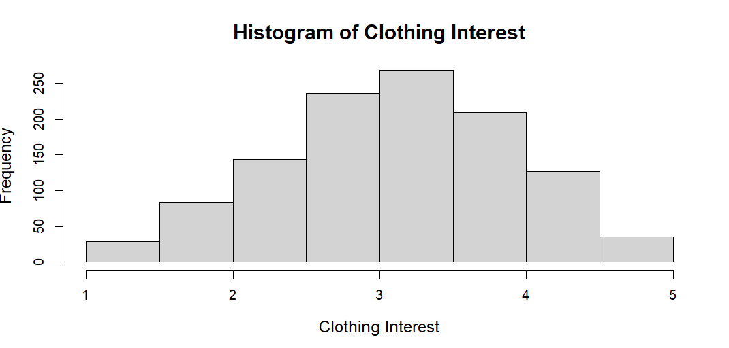

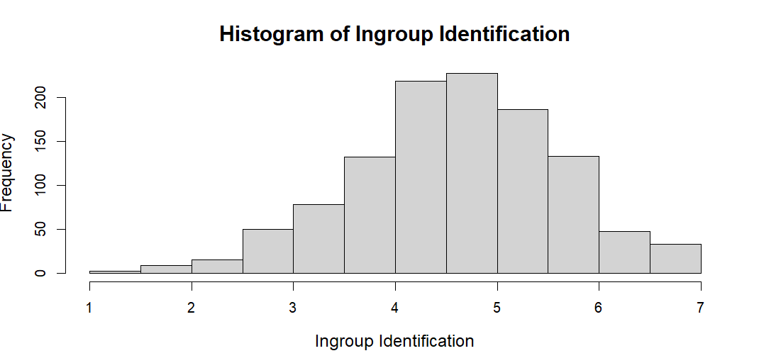

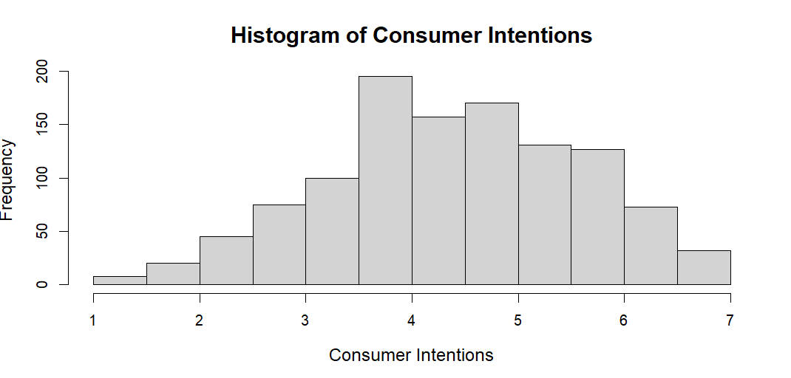

**Table #**

*Descriptive Statistics for Continuous Variables with Missing Data across Each Imputed Set*

| Imputed Set | Variable | Original *n* | *# of Imputed* | *M* | *SD* | *Skew* | *Min* | *Max* | *Mdn* |
| --- | --- | --- | --- | --- | --- | --- | --- | --- | --- |
| 1 | Biospheric Values | 1,119 | 14 | 5.85 | 1.00 | -1.08 | 1 | 7 | 6 |
| Altruistic Values | 1,120 | 13 | 6.21 | 0.80 | -1.91 | 1 | 7 | 6.50 |
| Egoistic Values | 1,119 | 14 | 5.00 | 0.92 | -0.39 | 1 | 7 | 5 |
| Hedonic Values | 1,120 | 13 | 6.05 | 0.79 | -1.44 | 1 | 7 | 6.33 |
| Self-deceptive Enhancement | 1,118 | 15 | 3.72 | 0.85 | 0.14 | 1 | 7 | 3.72 |
| Impression Management | 1,119 | 14 | 4.01 | 0.85 | 0.26 | 1 | 7 | 4 |
| Age | 1,030 | 103 | 19.8 | 1.93 | 4.65 | 18 | 50 | 19.18 |
| 2 | Biospheric Values | 1,119 | 14 | 5.85 | 0.99 | -1.08 | 1 | 7 | 6 |
| Altruistic Values | 1,120 | 13 | 6.20 | 0.81 | -1.89 | 1 | 7 | 6.50 |
| Egoistic Values | 1,119 | 14 | 4.99 | 0.92 | -0.38 | 1 | 7 | 5 |
| Hedonic Values | 1,120 | 13 | 6.05 | 0.80 | -1.43 | 1 | 7 | 6.33 |
| Self-deceptive Enhancement | 1,118 | 15 | 3.72 | 0.86 | 0.15 | 1 | 7 | 3.72 |
| Impression Management | 1,119 | 14 | 4.01 | 0.85 | 0.26 | 1 | 7 | 4 |
| Age | 1,119 | 14 | 19.87 | 1.93 | 4.68 | 18 | 50 | 19 |
| 3 | Biospheric Values | 1,119 | 14 | 5.85 | 1.00 | -1.10 | 1 | 7 | 6 |
| Altruistic Values | 1,120 | 13 | 6.21 | 0.81 | -1.91 | 1 | 7 | 6.50 |
| Egoistic Values | 1,119 | 14 | 5.00 | 0.92 | -0.39 | 1 | 7 | 5 |
| Hedonic Values | 1,120 | 13 | 6.05 | 0.79 | -1.44 | 1 | 7 | 6.33 |
| Self-deceptive Enhancement | 1,118 | 15 | 3.72 | 0.85 | 0.16 | 1 | 7 | 3.72 |
| Impression Management | 1,119 | 14 | 4.01 | 0.85 | 0.25 | 1 | 7 | 4 |
| Age | 1,119 | 14 | 19.90 | 1.94 | 4.57 | 18 | 50 | 19.29 |
| 4 | Biospheric Values | 1,119 | 14 | 5.85 | 0.99 | -1.10 | 1 | 7 | 6 |
| Altruistic Values | 1,120 | 13 | 6.21 | 0.81 | -1.90 | 1 | 7 | 6.50 |
| Egoistic Values | 1,119 | 14 | 5.00 | 0.92 | -0.40 | 1 | 7 | 5 |
| Hedonic Values | 1,120 | 13 | 6.06 | 0.79 | -1.45 | 1 | 7 | 6.33 |
| Self-deceptive Enhancement | 1,118 | 15 | 3.72 | 0.85 | 0.12 | 1 | 7 | 3.72 |
| Impression Management | 1,119 | 14 | 4.00 | 0.85 | 0.24 | 1 | 7 | 4 |
| Age | 1,119 | 14 | 19.88 | 1.94 | 4.63 | 18 | 50 | 19 |
| 5 | Biospheric Values | 1,119 | 14 | 5.85 | 1.00 | -1.11 | 1 | 7 | 6 |
| Altruistic Values | 1,120 | 13 | 6.21 | 0.81 | -1.91 | 1 | 7 | 6.50 |
| Egoistic Values | 1,119 | 14 | 4.99 | 0.92 | -0.39 | 1 | 7 | 5 |
| Hedonic Values | 1,120 | 13 | 6.05 | 0.79 | -1.45 | 1 | 7 | 6.33 |
| Self-deceptive Enhancement | 1,118 | 15 | 3.72 | 0.86 | 0.15 | 1 | 7 | 3.72 |
| Impression Management | 1,119 | 14 | 4.00 | 0.85 | 0.26 | 1 | 7 | 4 |
| Age | 1,119 | 14 | 19.89 | 1.92 | 4.69 | 18 | 50 | 19.14 |

